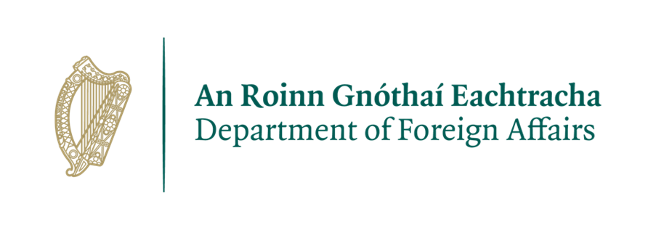

**Visa Assistant**

**Embassy of Ireland, Nigeria**

***Our mission is to promote and protect abroad the values, interests and economic well-being of Ireland and its people. We do this under the political direction of our Ministers, through our staff at home and through our Embassy network abroad.***

The Embassy is seeking to recruit a resourceful, proactive and flexible individual with previous experience in a similar environment to fill the position of Visa Assistant in the Embassy.

**Roles and Responsibilities:**

The precise range of duties will vary over time according to the needs of the Embassy, but will include the following:

* Responding to public queries received by the Embassy over telephone and email;
* Providing excellent customer service at the Embassy’s public office;
* Taking receipt of and processing visa applications for travel to Ireland;
* Entering visa applications onto the system;
* Printing of visas;
* Packing of passports and documents;
* Listing of packets despatched through VFS, and liaising with VFS;
* Verification of documents;
* Handling of post;
* Administration, including assisting the visa officers;
* Other duties as required from time to time and directed by the Head of Visas.

**Essential Requirements candidates must be able to demonstrate:**

* Fluency in English is essential;
* Previous experience in a similar role and environment;
* Ability to work to specific deadlines and deal with queries;
* Knowledge of visa and immigration matters;
* Excellent communication, written and administrative skills;
* Should be seIf-motivated, proactive, flexible and a team player;
* Candidates must have previous professional experience in a customer service provision role;
* The candidate must provide evidence of flexibility, efficiency and effectiveness showing strong organizational skills, attention to detail, able to work under pressure and to manage multiple tasks;
* High level of discretion, commitment, reliability, attention to detail and ability to work on own initiative;
* **All applicants must have a permanent legal right to reside and work in Nigeria**

**Desirable Skills and Experience:**

* A good understanding of the role of the Department of Justice and the Embassy;
* The successful applicant will work alongside other local employees of the Embassy, and will report directly to the diplomatic staff in the Mission. Previous experience in a diplomatic mission.
* Experience in the verification of documents;

**Terms and conditions of employment:**

* The successful candidate will be hired on a fixed-term contractual basis and will be based at the Irish Embassy, Nigeria.
* Monday to Friday, 38 hours per week, with standard office hours from 8:30am to 5:00pm, with Fridays being 8.30am - 13.30pm.
* Annual Leave entitlement 20 days per annum.
* The salary for the position is N2,900,781 per annum, paid locally on a weekly basis. Salaries are paid direct to a bank account, therefore, the successful candidate must have a bank account.

**How to apply**

The Job Description and Application Form for this position are available on our website

www.dfa.ie/irish-embassy/nigeria/about-us/job-opportunities

Completed application forms should be sent via e-mail only to abujarecruitment@dfa.ie, with the subject line **Visa Assistant**.

**Applications must be received before 16:00 hrs. (Local time) on 15/12/2023**

(No applications will be accepted after this deadline)

Please note that only short listed applicants will be contacted.

**Selection Process:**

* Depending on the number of applications received, a short-listing of candidates to be called for a **competency-based** interview may be undertaken based on the Essential/Key Requirements above.
* It is planned that interviews will be held before the end of January 2024.
* A skills test may be included in the recruitment process;
* A second interview may be included in the recruitment process; and
* A panel may be set up depending on the calibre of candidates;

**General Data Protection Regulation:**

All personal information received will be kept in line with GDPR guidelines.

**Security Clearance for Local Staff**

Police security clearance will be sought in respect of individuals who come under consideration for appointment. Enquiries may also be made with the police force of any country in which the applicant under consideration for appointment resided. If unsuccessful, this information will be destroyed. If the applicant subsequently comes under consideration for another position, they will be required to supply this information again.

***Please note that canvassing will disqualify applicants.***

***The Embassy of Ireland, Nigeria is committed to a policy of Equal Opportunity.***