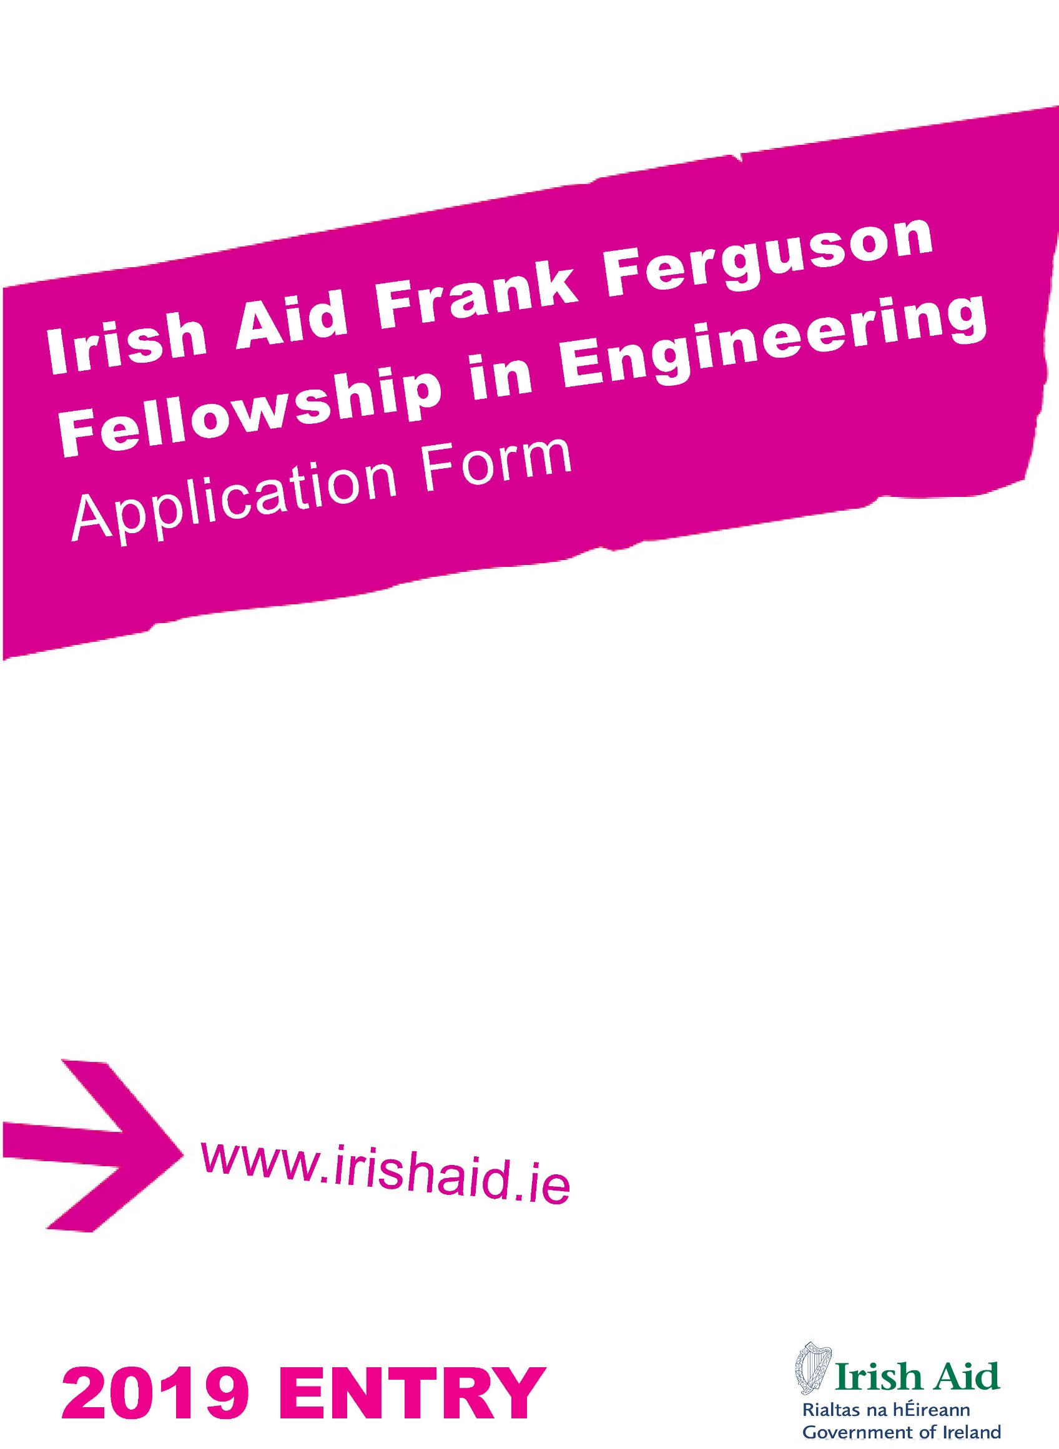
IRISH AID

The Government of Ireland’s official programme of assistance to developing countries, Irish Aid, is managed by the Department of Foreign Affairs and Trade (DFAT). The programme focuses on the fight against poverty and hunger in some of the world’s least developed countries, particularly in sub-Saharan Africa. Ireland works in partnership with governments and communities in their attempts to alleviate poverty through helping them meet basic needs and through strengthening their capacity to help themselves.

FRANK FERGUSON FELLOWSHIP IN ENGINEERING

Frank Ferguson was an engineer and innovator who dedicated fifty years of his life to promoting development in Zambia through practical projects. He was an influential individual who held the trust and confidence of decision makers in Zambia, including the President. Among his other achievements, he was awarded the Legion d’Honneur for his part in the Second World War.

Ferguson originally hailed from County Antrim, and held a strong sense of self-identity through his “Irishness”. In addition to contribution to the development of a young Zambian state, he acted to promote Irish culture, contributing strongly to awareness of and affection towards Ireland in Zambia. Ferguson passed away at the end of 2017.

In recognition of Ferguson's achievements, and in his memory, Irish Aid, in partnership with the Engineering Institution of Zambia and the National University of Ireland, Galway, have established a fellowship award that will fund one successful Zambian candidate each year to study on a masters level engineering programme in Ireland.

The scholarship award covers course fees, required flights, accommodation, monthly allowances, insurance and other incidental expenses. Eligible masters programmes in Ireland commence in the period August to September each year and, depending on the course, scholarships will run for between 10 and 16 months.

IRISH COUNCIL FOR INTERNATIONAL STUDENTS

The Irish Council for International Students (ICOS) – www.internationalstudents.ie – provides support for the management and administration of the IAFTP. ICOS is an independent non-profit organisation that promotes best practice in relation to the recruitment, access and support of international students in Irish education.

ELIGIBILITY REQUIREMENTS

To be eligible for the Frank Ferguson Fellowship, applicants must:

- be a citizen of Zambia and be residing in Zambia.
- hold a Degree in Engineering or related discipline with Merit or higher
- have achieved the necessary academic standard to be accepted onto a master’s level course of study in Engineering.
- be a member of the Engineering Institution of Zambia.
- have a minimum of two years' relevant work experience.
- be able to demonstrate a strong commitment to the development of Zambia.
- be able to take up the fellowship in the academic year for which it is offered.
- meet any relevant procedural requirements of the Government of Zambia.
- be able to demonstrate skills in academic English by achieving an appropriate score on a recognised test (e.g. IELTS 6.5).

An applicant will not be considered further in either of the following circumstances:

- They already hold a master’s qualification.
- They are currently working, or it is anticipated that they will work in the future, at our embassies or at headquarters. Those personnel who have worked with any of our embassies/missions in the past must allow a full year before becoming eligible to apply for a fellowship.

The closing date for receipt of applications to the Engineering Institution of Zambia is 30 November 2018.

All successful applicants will be required to sign a commitment to return to their home country within 14 days of completing their studies in Ireland.

APPLICATION REQUIREMENTS

Applications with unanswered questions or missing documentation will be deemed incomplete and will not be considered for a fellowship. Therefore, it is essential that you:

- fill out all required sections in this application form.
- include two recent passport-size photographs.
- include all relevant supporting documents and complete the checklist in Section 8.
- sign the application declaration in Section 9.
- submit a research proposal in an area linked to a social problem in Zambia. Applicants who are shortlisted by the Engineering Institution of Zambia will be invited to present their research proposal to the Embassy of Ireland and will be subject to further screening.

Your application will be photocopied. Pages should NOT be stapled together. Please do not use spiral or any other binding. Please print the completed application form in single-sided format only, and all accompanying documents must also be in single-sided format only.

SELECTION OF COURSE CHOICES

You must select from the following list of courses offered by the National University of Ireland, Galway:

  - Master of Civil Engineering (1MEC1)
  - ME in Energy Systems Engineering (1MEES1)
  - MSc in Water Resource Engineering (GYE23)
  - MSc in Mechanical Engineering (1MSME1)
  - ME in Electrical & Electronic Engineering (1MEEE1)

Courses should be listed on the application form according to first and second preference, and are an important consideration in the review of applications.

You should ensure that you hold the specified qualifications and academic grades required for the academic courses you intend applying for. These can be found on the relevant college website. It is your responsibility to ensure that your academic qualifications are of sufficient standard for your chosen course.

Please choose your courses carefully. You will not normally be permitted to revise your choices after submission, unless a programme does not run. Applicants are therefore advised to thoroughly research their course choices.

SUBMITTING APPLICATIONS

Completed applications should be submitted by post before 30 November 2018 to:

Frank Ferguson Fellowship Application
Engineering Institution of Zambia
CL/7 Brenthood Drive, Longacres
P.O. Box 51084

SELECTION PROCESS

Selection Round 1 / English Testing

The Engineering Institution of Zambia will conduct an initial shortlisting of applicants. Unless the applicant already holds a valid IELTS test result, applicants who meet the necessary criteria will be required to sit an IELTS academic English test. Tests are to be taken in January or February 2019. Arrangements, including payment of the test fee, will be organised by the Embassy of Ireland. (Applicants who already hold a suitable IELTS certificate should submit this with their application form).

TIP: You are advised to work through the practice materials at www.ielts.org and attend a preparation session, if available. You should note that even people who regularly speak English can find the test a challenge. In a recent application year, approximately two-thirds of applicants tested did not get the necessary score to be considered further.

Selection Round 2 / Course Applications

Applicants who are shortlisted by the Engineering Institution of Zambia will be invited to present their research proposal to the Embassy of Ireland and will be subject to further screening. The individual who will be progressing as a candidate will be informed in April 2019, and will then be contacted by ICOS with information on applying for their chosen college course(s). Application fees for courses in Ireland will be paid by ICOS provided applications are made after notification from ICOS. Application fees paid prior to notification by ICOS will not be reimbursed. Applicants are advised not to apply for courses in Ireland until such time as they are notified by ICOS to proceed, when full application guidance will be provided. At that stage, the applicant will be responsible for ensuring that they submit their application to the college, including all relevant supporting documentation, and for keeping ICOS updated with the progress of their application.

Fellowship Awards

The successful candidate will be announced in April, 2019. Only when the candidate successfully gains a course place, and provides documentation to ICOS confirming this, will the fellowship award be confirmed. This will likely happen in June, 2019. Please note, no candidate is guaranteed an award, even if all fellowship criteria are met.

If offered an Irish Aid fellowship, candidates will be required to:

- undergo a medical examination prior to confirmation of the fellowship award, and
- satisfy Irish immigration requirements.

Further Information

Information on the Frank Ferguson Fellowship, including the application process, is available from the Embassy of Ireland in Zambia. You can contact the Embassy of Ireland at https://www.dfa.ie/irish-embassy/zambia/contact-us/general-queries/.

General information on all of Irish Aid’s fellowship programmes can also be accessed from the Fellowship website at www.irishaidfellowships.ie. General information on studying in Ireland is available on ICOS’ website at www.internationalstudents.ie.

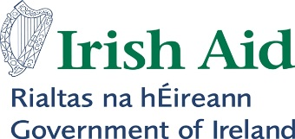  Ferguson Fellowship in Engineering – 2019 Application Form  Closing Date: 30 November 2018  This form is designed to be completed in Microsoft Word before being printed and signed  Your application will be photocopied. Pages should NOT be stapled together. Please do not use spiral or other binding. Use single-sided format for all forms and accompanying documents.  Additional application information is available at www.irishaidfellowships.ie | Please  attach two recent  passport-size photographs of  yourself here.  (Attach using glue  not staples or tape.  If your photos are together in a strip,  you do not need to  separate them)
SECTION ONE: PERSONAL INFORMATION
1a. Please write your full name in the order it would appear in an official document. This must match the name recorded in your passport if you have one.

Full Name:

1b. Name that you are known by (i.e. your first name or given name ):
2. Male Female

3. Date of Birth / / (Day / Month / Year)

4. Place of Birth

5. Nationality

6. Please give an email address for an account which is checked regularly. It is vital that you can be contacted by email regarding your application. If writing in an email address it should be clear and legible. If you use more than one email address you are asked to list a second email address below.

Email:

Alternate Email:

SECTION TWO: PROPOSED COURSE(S)
7. In this section, you should list the course title and academic institution for your first and second choice taught Masters courses. You are required to specify a particular course and academic institution in each case, not give a general course type.

You must select courses from the list of courses on page iii of the information section at the beginning of this form. Courses should be listed according to first and second preference and are an important consideration in the review of applications.

You should ensure that you hold the specified qualifications and academic grades required for the academic courses you intend applying for. These can be found on the relevant college website. It is your responsibility to ensure that your academic qualifications are of sufficient standard for your chosen course.

Please choose your courses carefully. You will not normally be permitted to revise your choices after submission, unless a programme does not run. Applicants are therefore advised to thoroughly research their course choices.

Courses must begin no earlier than July 2018.

First Course Choice

Name of Educational Institute: National University of Ireland, Galway

Full title of Course:

Course Code : (if available - can be found on course website)

Course start date: / (Month/Year) Course Duration:

Second Course Choice

Name of Educational Institute: National University of Ireland, Galway

Full title of Course:

Course Code: (if available - can be found on course website)

Course start date: / (Month/Year) Course Duration:

SECTION THREE: EDUCATION, QUALIFICATIONS AND SCHOLARSHIPS
8. You must provide a certified copy of the academic transcripts and completion certificate for each higher education qualification you have completed (see note in Section Eight regarding certified documents). Include a certified copy of the grade assessment schedule for each qualification.

Qualification | Educational Institution | Dates  From – To  (Month/Year) | Location | Final Grade Achieved

9. Please give details of any relevant professional qualifications awarded including dates, awarding body and type of award received.

10. Please give details of any educational or vocational training courses attended (other than those mentioned in Q8/9), including dates, training body and certification received, if applicable.

11. Have you previously received a higher education scholarship or award funded by any government or international organisation?

Yes No

If you answered Yes, write the name of the scholarship, the year(s) on scholarship and the name of the qualification or course undertaken.

i.

ii.

12. Have you ever previously applied for an Irish Aid Fellowship?

Yes No

If yes, please list year(s) in which you previously applied and if you were successful:

13. Have you applied, or are you intending to apply, for another scholarship at the same time as this application?

Yes No

If you answered Yes, provide the full name of the sponsor and the scholarship.

Sponsor:

Scholarship:

SECTION FOUR : EMPLOYMENT DETAILS
14. Please provide the following information in relation to your current employment:

Employing Organisation:

Address (please include city and country):

Telephone: Fax:

E-mail:

15. What type of organisation do you work for?

Local Government Community/Non-Government Organisation (NGO)
Central Government Faith-based Organisation
Other public sector organisation International NGO
Multilateral Agency Other (please state):

16. Date you started with this organisation: / / (Day/Month/Year)

Title of current post:

Date you started in this post: / / (Day/Month/Year)

List in chronological order the previous positions held in this organisation and dates (please provide month and year of commencement of position):

17. Briefly describe the work of your current employer:

18. Please provide details of your current responsibilities:

19. Please provide information, on your previous employment, if applicable.

Name of Organisation | Address | Dates  From-To  (Month and Year) | Location | Position Held  Tasks and Responsibilities

SECTION FIVE: STATEMENT OF INTENT

Please complete this section paying careful attention to the suggested word count. Please note that the quality of your answers will be a key factor in how your application will be graded by the selection panel.

20. The key achievements in my career to date (approximately 400 words)

21. Why I want to pursue my nominated course(s) (approximately 400 words)

22. How I will use my new skills and knowledge when I return (approximately 200 words)

23. How I believe my proposed study will contribute to future development in my country
(approximately 200 words)

SECTION SIX : ENGLISH LANGUAGE COMPETENCY
24. Have you completed an IELTS (International English Language Testing System) academic test?*

No Yes

I have attached the original copy of my IELTS result to this application form.

Date of test: / / (Day/Month/Year)

Overall IELTS (academic stream) score:

Listening band: Reading band: Writing band: Speaking band:

* You will be required to demonstrate the Irish Aid FTP minimum IELTS English language proficiency level. This is an overall IELTS score of 6.5. No exceptions are made.

Please note that entry to some courses may require an overall IELTS score above 6.5 and/or a minimum score in specific bands. Applicants should always refer to the course information for further details.

Shortlisted applicants will be invited to sit an IELTS English language test if they do not already hold a certificate at the required level or their certificate would be more than 24 months old at the time of beginning studies.

For additional information see p iii.

SECTION SEVEN: SUPPLEMENTARY INFORMATION
25a. Do you have a passport? Yes No (Go to Q27)

b. Country issuing passport:

c. Date of expiry : / / * (Day/Month/Year)

* For study in Ireland, your passport should be valid for the duration of your study period.

d. If you hold a passport for another country or a diplomatic passport, please give details:

26. Have you ever been convicted of a criminal offence? Yes No

If the answer is Yes, please provide details of the offence for which you were convicted, including the nature of the offence and the sentence received.

27. Please provide (a) a home mailing address (not a PO Box) where registered post can be delivered and signed for, and (b) a PO Box address if you have one.

a) Home Address (please include city and country):

b) PO Box Address, if applicable (please include city and country). Please indicate if you wish to use this address as your primary mailing address for correspondence purposes by ticking the box:

c) Contact phone numbers: (Please give at least two numbers if possible, e.g. work, mobile, landline)

Your main telephone number:

Other telephone number (1):

Other telephone number (2):

28. Name someone who can be contacted in an emergency.

Name:
Relationship to you (e.g. spouse, father, mother, sibling):
Home Address (please include city and country):

What telephone numbers can be used to contact them? (Please give at least two numbers if possible)

Main telephone number:

Other telephone number:

Does this person speak English? Yes No

Clearly write an email address for an account which they check regularly.

Email:

SECTION EIGHT: DOCUMENTATION CHECKLIST
All relevant documents listed below must be included with your application, in the sequence shown.

Supporting documents must be certified true copies of original documents with the official stamp and signature of a justice of the peace, solicitor, notary public, an official from an embassy of Ireland, or another authorised official. Photocopies of certified documents are not acceptable but a certified photocopy of a document with an original certification is acceptable. It is recommended that you obtain a minimum of three certified copies of all of your documents as you will need to provide certified copies for your course applications, as well as retain a copy for yourself. Where original documents are not in English, you must provide certified true copies of official English translations.

You should mark each box below with ‘X’ to indicate that the document is present. If you do not possess a particular document (e.g. birth certificate) you should explain in the notes section below.

You are advised to make electronic scans of all documents submitted with your application.

Essential

A certified copy of the completion or graduation certificate for each higher education qualification that you have completed (in English).
A certified copy of the academic transcript for all higher education qualifications and the grading schedule for each qualification (in English).
Letters from your two academic referees with original signatures (Q21). E-signatures are not accepted.
A certified copy of the identity page of your passport
A reference letter from your employer on official letterhead, supporting your fellowship application for your proposed course of study. If you are not currently working, please provide a reference letter from a past employer, or another similar reference letter.

If applicable:

A certified copy of your birth certificate (in English), only applicable where no passport is provided.
A certified copy of official evidence of any name change (in English).
An original IELTS academic English test certificate. Photocopies will not be accepted. Test results must be no more than 24 months old by the commencement of study.

Do not include copies of certificates from short courses or for non-degree level programmes.

NOTES ON DOCUMENTATION:

SECTION NINE: DECLARATION
I am in good health and if accepted for the Frank Ferguson Fellowship in Engineering will undertake the necessary medical examinations and provide the required medical certificates.

I give my permission for information and documents submitted as part of my application to be shared with:
- the managing agency for Irish Aid Fellowships;
- the consultant for Irish Aid’s fellowship selection process; and
- appropriate staff of my nominated Higher Education Institutions, as required, regarding any course applications and place offers;
- any other individuals, companies and/or organisations as necessary to make arrangements related to my participation in the Fellowship Programme.
When your application form is received, we create a record in your name, which contains much of the personal information you have supplied. This personal record is used solely in processing your candidature. Such information held is subject to the rights and obligations set out in the Data Protection Acts, 1988 and 2003.

I understand the purpose for which Irish Aid fellowships are awarded and the necessity to abide by the conditions specified.

I certify that all the information I have given is true, complete and accurate to the best of my knowledge.

Signature: Date: / / (Day/Month/Year)

